Donald Super Developmental self-concept
Donald Super’s career model is based on the belief that self-concept changes over time and develops as a result of experience.

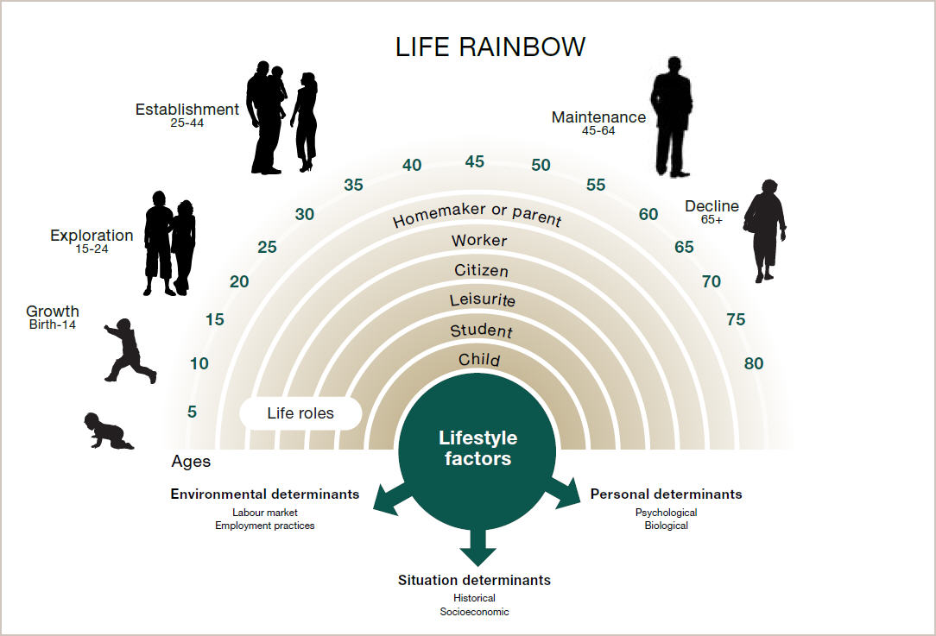

One of Donald Super’s greatest contributions to career development has been his emphasis on the importance of the development of self-concept. According to Super, self-concept changes over time and develops as a result of experience. As such, career development is lifelong.

Super’s five life and career development stages
Super developed the theories and work of colleague Eli Ginzberg. Super felt that Ginzberg’s work had weaknesses, which he wanted to address. Super extended Ginzberg’s work on life and career development stages from three to five, and included different sub-stages.

Stage 1: Growth | Age 0–14 | Characteristics: Development of self-concept, attitudes, needs and general world of work
Stage 2: Exploration | Age 15–24 | Characteristics: “Trying out” through classes, work experience, hobbies. Tentative choice and skill development
Stage 3: Establishment | Age 25–44 | Characteristics: Entry-level skill building and stabilisation through work experience
Stage 4: Maintenance | Age 45-64 | Characteristics: Continual adjustment process to improve position
Stage 5: Decline | Age 65+ | Characteristics: Reduced output, prepare for retirement

Developmental tasks at the different stages
Super argues that occupational preferences and competencies, along with an individual’s life situations all change with time and experience.
Super developed the concept of vocational maturity, which may or may not correspond to chronological age: people cycle through each of these stages when they go through career transitions.

Decline
In adolescence:  Giving less time to hobbies. | In early adulthood:  Reducing sports participation. | In middle adulthood:  Focusing on essentials. | In late adulthood:  Reducing working hours.

Maintenance
In adolescence:  Verifying current occupational choice. | In early adulthood:  Making occupational position secure. | In middle adulthood:  Holding one's own against competition. | In late adulthood:  Keeping what one enjoys.

Establishment
In adolescence:  Getting started in a chosen field. | In early adulthood:  Settling down in a suitable position. | In middle adulthood:  Developing new skills. | In late adulthood:  Doing things one has wanted to do.

Exploration
In adolescence:  Learning more about opportunities. | In early adulthood:  Finding desired opportunity. | In middle adulthood:  Identifying new tasks to work on. | In late adulthood:  Finding a good retirement place.

Growth
In adolescence:  Developing a realistic self-concept. | In early adulthood:  Learning to relate to others. | In middle adulthood:  Accepting one's own limitations. | In late adulthood:  Developing and valuing non-occupational roles.

